**Assignment 9.2**

**Problem 1:**

Create an HBase table named 'clicks' with a column family 'hits' such that it should be able to store last 5 values of qualifiers inside 'hits' column family.

* Start all the services
* start-hbase.sh
* Enter hbase shell

**Sol:**

* Create Table name ‘ clicks’ with column family ‘hits’

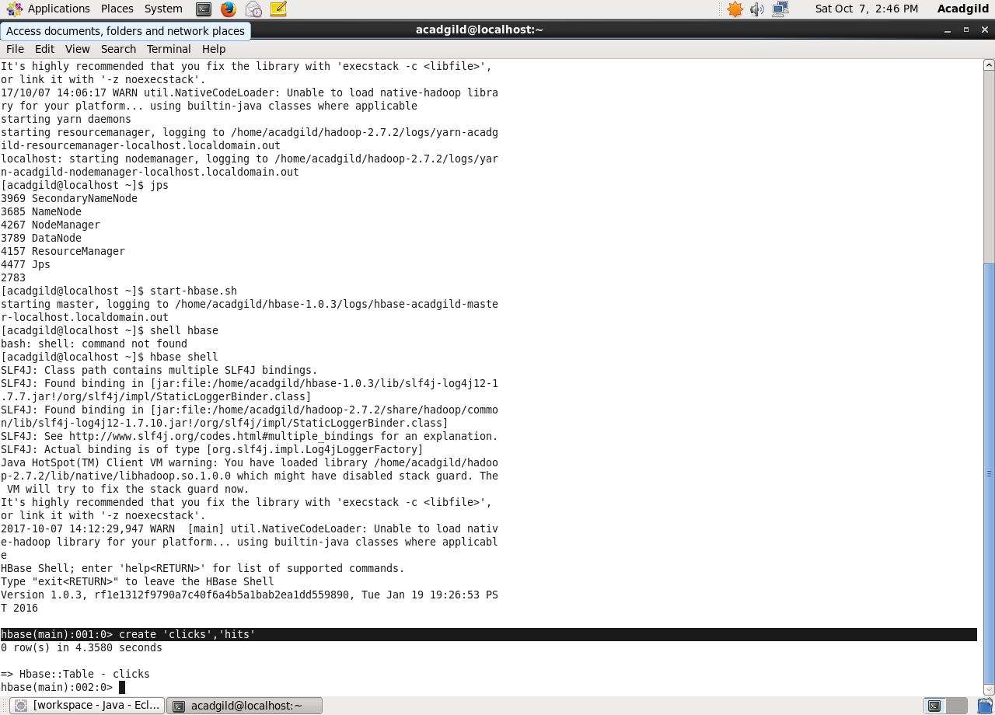

* Disable the table
* Alter table clicks to include 5 versions of hits and Enable.

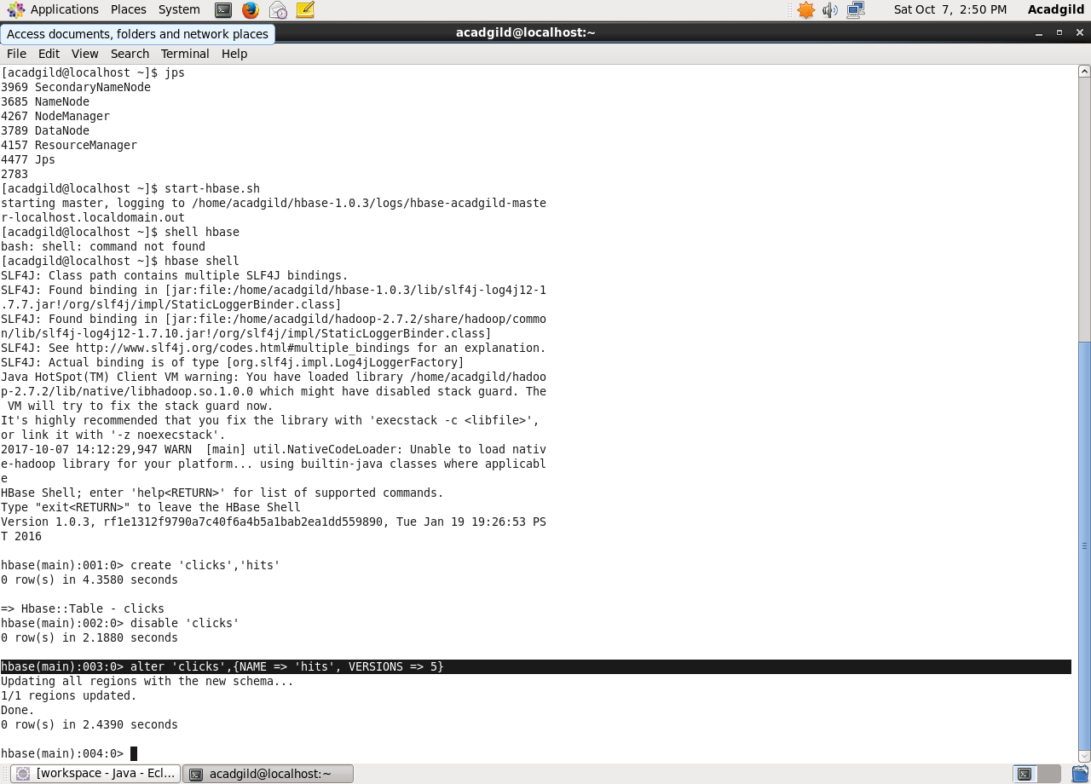

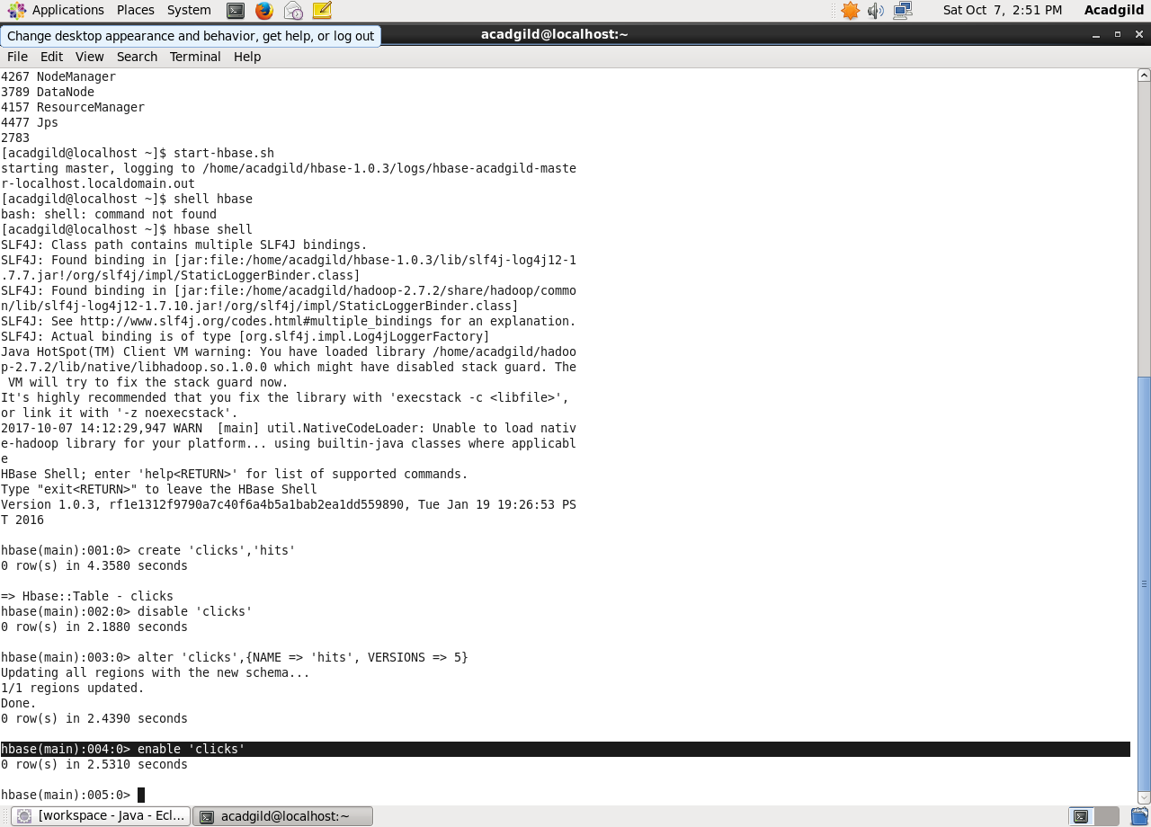

**Problem 2:**

Add few records in the table and update some of them. Use IP Address as row-key. Scan the table to view if all the previous versions are getting displayed.

**Sol:**

* Enter values for the table **clicks** using **Put**

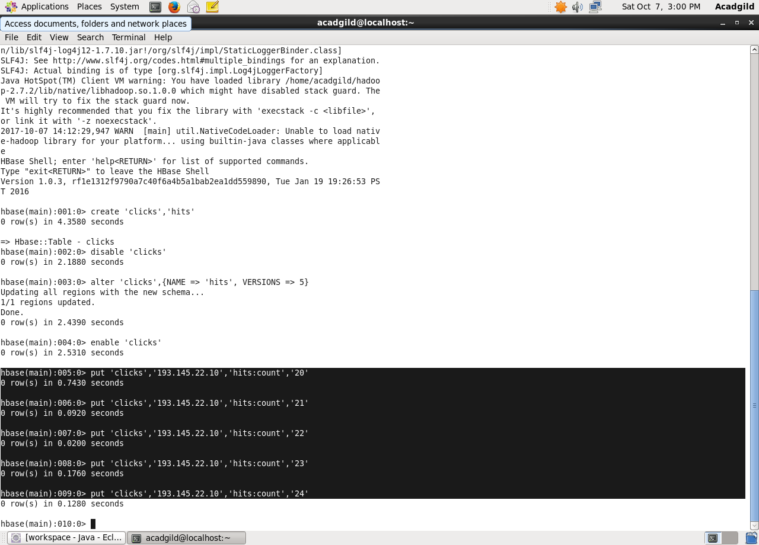

* Scan table ‘**clicks’**  to view the previous versions.

